Project details are available from page 13

1. ConfigMap
ConfigMap is a Kubernetes object that lets you store configuration data in key-value pairs. It is used to manage non-sensitive configuration information separately from the application code.
Creating a ConfigMap
You can create a ConfigMap from a literal value or from a file. Here’s an example of creating a ConfigMap from literal values:

apiVersion: v1
kind: ConfigMap
metadata:
name: web-config
data:
DATABASE_URL: "jdbc:mysql://db-server:3306/mydatabase"
APP_ENV: "production"

Using ConfigMap in a Pod
To use the ConfigMap in a Pod, you need to reference it in your Pod specification. Here’s how you can inject ConfigMap values as environment variables:

apiVersion: v1
kind: Pod
metadata:
name: web-app
spec:
containers:
- name: web-container
image: my-web-app:latest
env:
- name: DATABASE_URL
valueFrom:
configMapKeyRef:
name: web-config
key: DATABASE_URL
- name: APP_ENV
valueFrom:
configMapKeyRef:
name: web-config
key: APP_ENV

Example Use Case: Mounting ConfigMap as a File
Sometimes, an application may require configuration files. You can mount a ConfigMap as a file inside a container.

apiVersion: v1
kind: ConfigMap
metadata:
name: config-files
data:
config.yaml: |
database:
url: "jdbc:mysql://db-server:3306/mydatabase"
environment: "production"

Mount the ConfigMap as a volume in the Pod:

apiVersion: v1
kind: Pod
metadata:
name: web-app
spec:
containers:
- name: web-container
image: my-web-app:latest
volumeMounts:
- name: config-volume
mountPath: /etc/config
volumes:
- name: config-volume
configMap:
name: config-files

The configuration file config.yaml will be available at /etc/config/config.yaml inside the container.

2. Secrets
Secrets is a Kubernetes object designed to hold sensitive data such as passwords, OAuth tokens, and SSH keys. Secrets ensure that sensitive information is stored securely.
Creating a Secret
You can create a Secret from literal values or from files. Here’s an example of creating a Secret from literal values:
apiVersion: v1
kind: Secret
metadata:
name: db-credentials
type: Opaque
data:
username: dXNlcm5hbWU= # base64 encoded 'username'
password: cGFzc3dvcmQ= # base64 encoded 'password'

Using Secrets in a Pod
To use the Secret in a Pod, reference it in your Pod specification and inject it as environment variables:

apiVersion: v1
kind: Pod
metadata:
name: web-app
spec:
containers:
- name: web-container
image: my-web-app:latest
env:
- name: DB_USERNAME
valueFrom:
secretKeyRef:
name: db-credentials
key: username
- name: DB_PASSWORD
valueFrom:
secretKeyRef:
name: db-credentials
key: password

Example Use Case: Mounting Secrets as Files
For applications that require secrets as files, you can mount the Secret as a volume inside a container.

apiVersion: v1
kind: Secret
metadata:
name: ssh-keys
type: Opaque
data:
ssh-privatekey: <base64-encoded-private-key>
ssh-publickey: <base64-encoded-public-key>

Mount the Secret as a volume in the Pod:

apiVersion: v1
kind: Pod
metadata:
name: web-app
spec:
containers:
- name: web-container
image: my-web-app:latest
volumeMounts:
- name: ssh-volume
mountPath: /etc/ssh
readOnly: true
volumes:
- name: ssh-volume
secret:
secretName: ssh-keys

The SSH keys will be available at /etc/ssh inside the container.

3. Environment Variables
Environment variables are a way to pass configuration settings to applications running inside containers. They can be defined directly in the Pod specification or sourced from ConfigMaps and Secrets.
Example Use Case: Passing Configuration to a Container
Environment variables can be used to pass various configurations like application mode, API endpoints, and feature flags to the container.
Defining Environment Variables in Pod Specification

apiVersion: v1
kind: Pod
metadata:
name: web-app
spec:
containers:
- name: web-container
image: my-web-app:latest
env:
- name: APP_MODE
value: "production"
- name: API_ENDPOINT
value: "https://api.example.com"

Example Use Case: Using Environment Variables from ConfigMaps and Secrets
Combining ConfigMaps and Secrets with environment variables provides a flexible and secure way to manage configurations.
Using ConfigMap and Secret Environment Variables Together
apiVersion: v1
kind: Pod
metadata:
name: web-app
spec:
containers:
- name: web-container
image: my-web-app:latest
env:
- name: DATABASE_URL
valueFrom:
configMapKeyRef:
name: web-config
key: DATABASE_URL
- name: APP_ENV
valueFrom:
configMapKeyRef:
name: web-config
key: APP_ENV
- name: DB_USERNAME
valueFrom:
secretKeyRef:
name: db-credentials
key: username
- name: DB_PASSWORD
valueFrom:
secretKeyRef:
name: db-credentials
key: password

Autoscaling in Kubernetes

1. Horizontal Pod Autoscaler (HPA)
1.1. Define a Deployment

apiVersion: apps/v1
kind: Deployment
metadata:
name: web-app
spec:
replicas: 2
selector:
matchLabels:
app: web-app
template:
metadata:
labels:
app: web-app
spec:
containers:
- name: web-container
image: my-web-app:latest
ports:
- containerPort: 80
resources:
requests:
cpu: "500m"
limits:
cpu: "1"

1.2. Apply the Deployment

kubectl apply -f deployment.yaml

1.3. Create a Service

apiVersion: v1
kind: Service
metadata:
name: web-service
spec:
selector:
app: web-app
ports:
- protocol: TCP
port: 80
targetPort: 80
type: LoadBalancer

1.4. Apply the Service

kubectl apply -f service.yaml

1.5. Create an HPA
Define an HPA to scale the number of pods based on CPU utilization:

apiVersion: autoscaling/v2beta2
kind: HorizontalPodAutoscaler
metadata:
name: web-app-hpa
spec:
scaleTargetRef:
apiVersion: apps/v1
kind: Deployment
name: web-app
minReplicas: 2
maxReplicas: 10
metrics:
- type: Resource
resource:
name: cpu
target:
type: Utilization
averageUtilization: 50

1.6. Apply the HPA

kubectl apply -f hpa.yaml

Vertical Pod Autoscaler (VPA)
2.1. Define a Deployment
Create a Deployment for the batch job:

apiVersion: apps/v1
kind: Deployment
metadata:
name: batch-job
spec:
replicas: 1
selector:
matchLabels:
app: batch-job
template:
metadata:
labels:
app: batch-job
spec:
containers:
- name: batch-container
image: my-batch-job:latest
resources:
requests:
cpu: "500m"
memory: "1Gi"
limits:
cpu: "1"
memory: "2Gi"

2.2. Apply the Deployment
kubectl apply -f deployment.yaml

2.3. Create a VPA
Define a VPA to manage the resource requests and limits for the Pod:
apiVersion: verticalpodautoscaler.k8s.io/v1
kind: VerticalPodAutoscaler
metadata:
name: batch-job-vpa
spec:
targetRef:
apiVersion: apps/v1
kind: Deployment
name: batch-job
updatePolicy:
updateMode: Auto

2.4. Apply the VPA
kubectl apply -f vpa.yaml

Linux Scripts

Viewing Processes (ps, top)

Use Cases:
- System Monitoring:
  - Example: An administrator needs to check the status of all running processes to ensure that critical applications are running smoothly.
Commands:
ps aux # Displays detailed information about all running processes
top # Interactive view of system processes, updates in real time

- Troubleshooting Performance Issues:
  - Example: A developer notices that the server is slow and needs to find out which processes are consuming the most CPU or memory.
Commands:
top # Look for processes consuming high CPU or memory
ps -eo pid,comm,%cpu,%mem --sort=-%cpu | head # Display top 10 processes by CPU usage

- Identifying Zombie Processes:
  - Example: The system administrator is dealing with processes that are stuck in the “zombie” state.
Commands:
ps aux | grep 'Z' # Finds processes in a zombie state

Examples:
Example 1:
ps aux | grep nginx
- Finds processes related to the nginx web server.
Example 2:
top -u username
- Displays processes owned by a specific user.

Managing Processes (kill, nice)

Use Cases:
- Stopping Unresponsive Applications:
  - Example: A user needs to stop a process that has become unresponsive or is consuming excessive resources.
Commands:
kill -9 12345 # Forcefully terminates the process with PID 12345

- Adjusting Process Priority:
  - Example: A system administrator wants to lower the priority of a process to ensure it does not hog resources.
Commands:
nice -n 10 command # Start a process with a lower priority
renice +10 -p 12345 # Change the priority of an existing process with PID 12345

- Gracefully Stopping Services:
  - Example: An admin needs to restart a service to apply configuration changes.
Commands:
kill -HUP 12345 # Sends a SIGHUP signal to the process to reload configuration

Examples:
Example 1:
killall -9 firefox
- Kills all processes named firefox.
Example 2:
nice -n -10 ./heavy_script.sh
- Runs heavy_script.sh with a higher priority.

Configure SSH

Shell Scripts

Writing Basic Shell Scripts

Use Cases:
- Automating Routine Tasks:
  - Example: A sysadmin wants to automate the backup of log files.
Commands:
#!/bin/bash
cp /var/log/syslog /backup/syslog-$(date +%F).log

- System Maintenance:
  - Example: A developer creates a script to clean up temporary files.
Commands:
#!/bin/bash
rm -rf /tmp/*
- Batch Processing:
  - Example: A data analyst needs to process multiple files in a directory.
Commands:
#!/bin/bash

process_file() {
local file="$1"
echo "Processing $file"
# Add more commands to process the file here
}

for file in /data/*.csv; do
process_file "$file"
done

Project 01

In this project, you will develop a simple Node.js application, deploy it on a local Kubernetes cluster using Minikube, and configure various Kubernetes features. The project includes Git version control practices, creating and managing branches, and performing rebases. Additionally, you will work with ConfigMaps, Secrets, environment variables, and set up vertical and horizontal pod autoscaling.

Project 01

Project Steps

1. Setup Minikube and Git Repository

Start Minikube:
minikube start

1.2 Set Up Git Repository
Create a new directory for your project:
mkdir nodejs-k8s-project
cd nodejs-k8s-project

Initialize Git repository:
git init

Create a .gitignore file:
node_modules/
.env
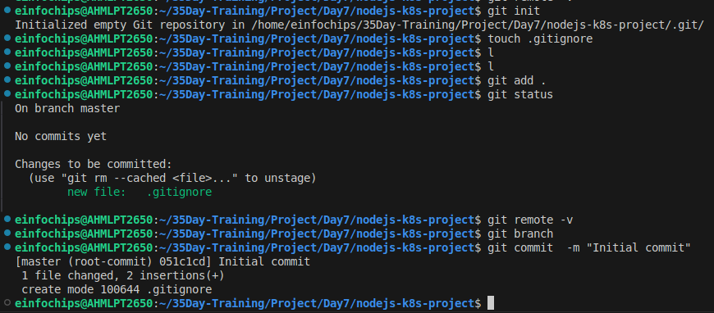
Add and commit initial changes:
git add .
git commit -m "Initial commit"

2. Develop a Node.js Application

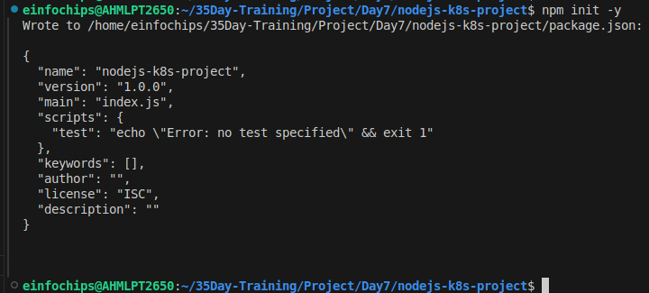
2.1 Create the Node.js App
Initialize the Node.js project:
npm init -y

Install necessary packages:
npm install express body-parser

Create app.js:
const express = require('express');
const bodyParser = require('body-parser');
const app = express();
const PORT = process.env.PORT || 3000;

app.use(bodyParser.json());

app.get('/', (req, res) => {
res.send('Hello, World!');
});

app.listen(PORT, () => {
console.log(`Server is running on port ${PORT}`);
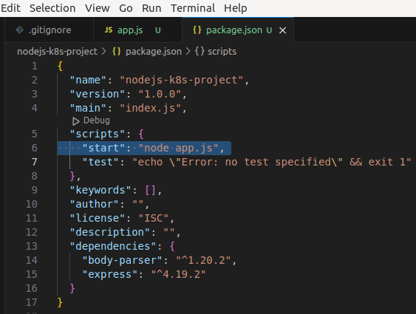
});

Update package.json to include a start script:
"scripts": {
"start": "node app.js"
}

2.2 Commit the Node.js Application
Add and commit changes:
git add .
git commit -m "Add Node.js application code"

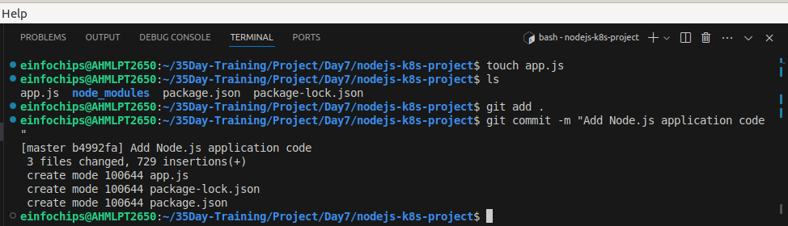
3. Create Dockerfile and Docker Compose

3.1 Create a Dockerfile
Add Dockerfile:
# Use official Node.js image i used FROM node:latest
FROM node:18

# Set the working directory
WORKDIR /usr/src/app

# Copy package.json and package-lock.json
COPY package*.json ./

# Install dependencies
RUN npm install

# Copy the rest of the application code
COPY . .

# Expose the port on which the app runs
EXPOSE 3000

# Command to run the application
CMD [ "npm", "start" ]

Create a .dockerignore file:
node_modules
.npm

3.2 Create docker-compose.yml (optional for local testing)
Add docker-compose.yml:
version: '3'
services:
app:
build: .
ports:
- "3000:3000"

Add and commit changes:
git add Dockerfile docker-compose.yml
git commit -m "Add Dockerfile and Docker Compose configuration"

4. Build and Push Docker Image

4.1 Build Docker Image
Build the Docker image:
docker build -t nodejs-app:latest .
Try to access app.js by node:18 image in browser port 3000.

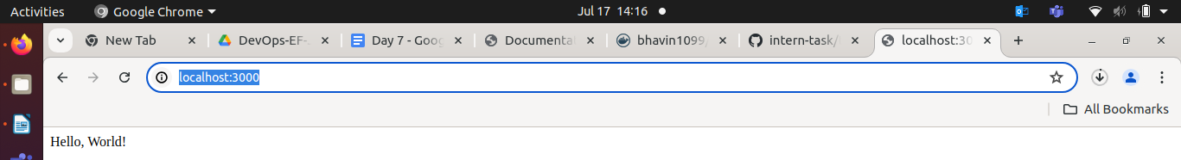
4.2 Push Docker Image to Docker Hub
Tag and push the image:
docker tag nodejs-app:latest your-dockerhub-username/nodejs-app:latest
docker push your-dockerhub-username/nodejs-app:latest

Add and commit changes:
git add .
git commit -m "Build and push Docker image"

5. Create Kubernetes Configurations

5.1 Create Kubernetes Deployment
Create kubernetes/deployment.yaml:
apiVersion: apps/v1
kind: Deployment
metadata:
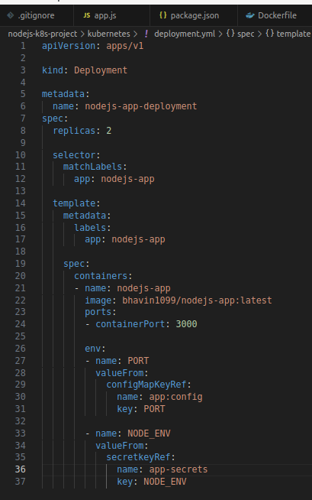
name: nodejs-app-deployment
spec:
replicas: 2
selector:
matchLabels:
app: nodejs-app
template:
metadata:
labels:
app: nodejs-app
spec:
containers:
- name: nodejs-app
image: your-dockerhub-username/nodejs-app:latest
ports:
- containerPort: 3000
env:
- name: PORT
valueFrom:
configMapKeyRef:
name: app-config
key: PORT
- name: NODE_ENV
valueFrom:
secretKeyRef:
name: app-secrets
key: NODE_ENV

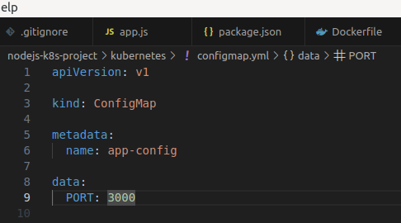
5.2 Create ConfigMap and Secret
Create kubernetes/configmap.yaml:
apiVersion: v1
kind: ConfigMap
metadata:
name: app-config
data:
PORT: "3000"
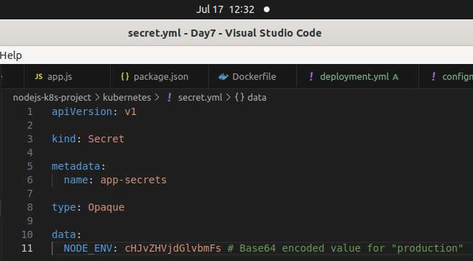
Create kubernetes/secret.yaml:
apiVersion: v1
kind: Secret
metadata:
name: app-secrets
type: Opaque
data:
NODE_ENV: cHJvZHVjdGlvbmFs # Base64 encoded value for "production"

Add and commit Kubernetes configurations:
git add kubernetes/
git commit -m "Add Kubernetes deployment, configmap, and secret"

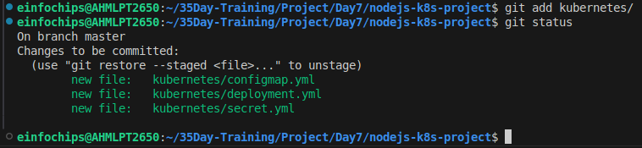
5.3 Apply Kubernetes Configurations
Apply the ConfigMap and Secret:
kubectl apply -f kubernetes/configmap.yaml
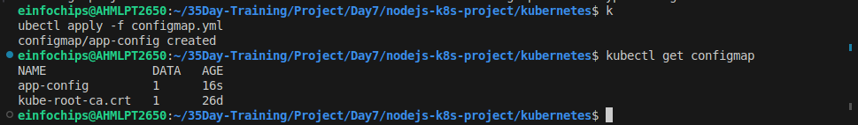
kubectl apply -f kubernetes/secret.yaml
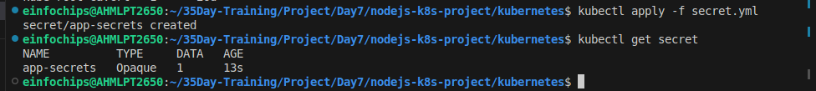
Apply the Deployment:
kubectl apply -f kubernetes/deployment.yaml

Here, when you deploy the deployment.yml file. And if you get error CreationError/ LoopBack error, that mean, your dockerimage not run & exited.
So, test your docker image locally then push it in docker registry.Then put it into deployment.yml file then kubectl apply -f deployment.yml
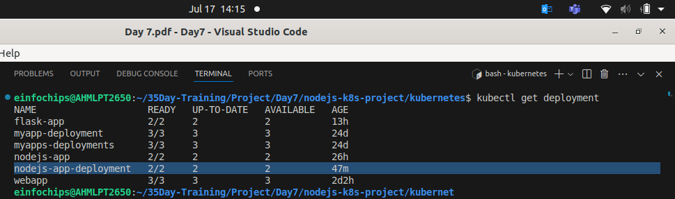

6. Implement Autoscaling

6.1 Create Horizontal Pod Autoscaler
Create kubernetes/hpa.yaml:
apiVersion: autoscaling/v2beta2 # here, v2beta2 not work, so, i write v2 only.
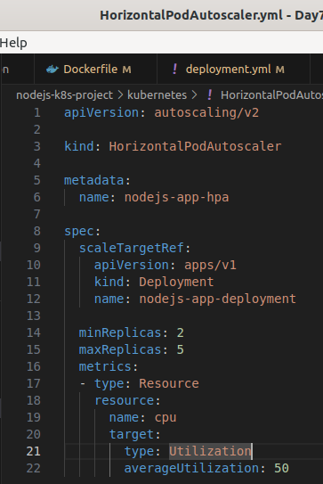
kind: HorizontalPodAutoscaler
metadata:
name: nodejs-app-hpa
spec:
scaleTargetRef:
apiVersion: apps/v1
kind: Deployment
name: nodejs-app-deployment
minReplicas: 2
maxReplicas: 5
metrics:
- type: Resource
resource:
name: cpu
target:
type: Utilization
averageUtilization: 50

Apply the HPA:
kubectl apply -f kubernetes/hpa.yaml

6.2 Create Vertical Pod Autoscaler
Create kubernetes/vpa.yaml:
apiVersion: autoscaling.k8s.io/v1beta2
kind: VerticalPodAutoscaler
metadata:
name: nodejs-app-vpa
spec:
targetRef:
apiVersion: apps/v1
kind: Deployment
name: nodejs-app-deployment
updatePolicy:
updateMode: "Auto"

Apply the VPA:
kubectl apply -f kubernetes/vpa.yaml
I got error no matches for kind “VerticalPodAutoscaler” in version”V2bet2”
User V2 only.

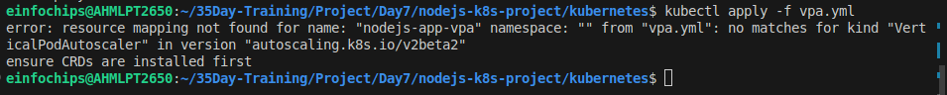
7. Test the Deployment

7.1 Check the Status of Pods, Services, and HPA
Verify the Pods:
kubectl get pods

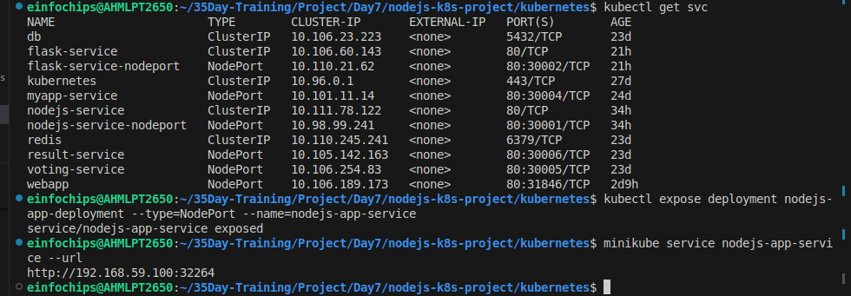
Verify the Services:
kubectl get svc

Verify the HPA:
kubectl get hpa

7.2 Access the Application
Expose the Service:
kubectl expose deployment nodejs-app-deployment --type=NodePort –name=nodejs-app-service
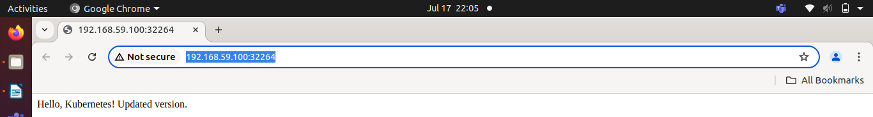
Get the Minikube IP and Service Port:
minikube service nodejs-app-service --url
- Access the Application in your browser using the URL obtained from the previous command.

8. Git Version Control

8.1 Create a New Branch for New Features
Create and switch to a new branch:
git checkout -b feature/new-feature

Make changes and commit:
# Make some changes
git add .
git commit -m "Add new feature"

Push the branch to the remote repository:
git push origin feature/new-feature

8.2 Rebase Feature Branch on Main Branch
Switch to the main branch and pull the latest changes:
git checkout main
git pull origin main

Rebase the feature branch:
git checkout feature/new-feature
git rebase main

Resolve conflicts if any, and continue the rebase:
git add .
git rebase --continue

Push the rebased feature branch:
git push origin feature/new-feature --force

9. Final Commit and Cleanup
Merge feature branch to main:
git checkout main
git merge feature/new-feature

Push the changes to the main branch:
git push origin main

Clean up:
git branch -d feature/new-feature
git push origin --delete feature/new-feature

Project 02

Deploy a Node.js application to Kubernetes with advanced usage of ConfigMaps and Secrets. Implement Horizontal Pod Autoscaler (HPA) with both scale-up and scale-down policies. The project will include a multi-environment configuration strategy, integrating a Redis cache, and monitoring application metrics.

Project Setup

1.1 Initialize a Git Repository
Create a new directory for your project and initialize Git:
mkdir nodejs-advanced-k8s-project
cd nodejs-advanced-k8s-project
git init

1.2 Create Initial Files
Create the initial Node.js application and Docker-related files:
npm init -y
npm install express redis body-parser

app.js

const express = require('express');
const bodyParser = require('body-parser');
const redis = require('redis');
const app = express();
const PORT = process.env.PORT || 3000;

// Connect to Redis
const redisClient = redis.createClient({
url: `redis://${process.env.REDIS_HOST}:${process.env.REDIS_PORT}`
});
redisClient.on('error', (err) => console.error('Redis Client Error', err));

app.use(bodyParser.json());

app.get('/', async (req, res) => {
const visits = await redisClient.get('visits');
if (visits) {
await redisClient.set('visits', parseInt(visits) + 1);
} else {
await redisClient.set('visits', 1);
}
res.send(`Hello, World! You are visitor number ${visits || 1}`);
});

app.listen(PORT, () => {
console.log(`Server is running on port ${PORT}`);
});

Dockerfile

FROM node:18

WORKDIR /usr/src/app

COPY package*.json ./

RUN npm install

COPY . .

EXPOSE 3000

CMD ["npm", "start"]

.dockerignore

node_modules
.npm

1. Build and push Docker image:

docker build -t your-dockerhub-username/nodejs-advanced-app:latest .
docker push your-dockerhub-username/nodejs-advanced-app:latest

Apply Kubernetes configurations:
kubectl apply -f kubernetes/

Access the application:
minikube service nodejs-advanced-app-service --url

2. Advanced Kubernetes Configuration

2.1 Deployment Configuration

Create `kubernetes/deployment.yaml` to deploy the Node.js application with Redis dependency:

```yaml
apiVersion: apps/v1
kind: Deployment
metadata:
name: nodejs-advanced-app-deployment
spec:
replicas: 2
selector:
matchLabels:
app: nodejs-advanced-app
template:
metadata:
labels:
app: nodejs-advanced-app
spec:
containers:
- name: nodejs-advanced-app
image: your-dockerhub-username/nodejs-advanced-app:latest
ports:
- containerPort: 3000
env:
- name: PORT
valueFrom:
configMapKeyRef:
name: app-config
key: PORT
- name: REDIS_HOST
valueFrom:
configMapKeyRef:
name: redis-config
key: REDIS_HOST
- name: REDIS_PORT
valueFrom:
configMapKeyRef:
name: redis-config
key: REDIS_PORT
- name: NODE_ENV
valueFrom:
secretKeyRef:
name: app-secrets
key: NODE_ENV
- name: redis
image: redis:latest
ports:
- containerPort: 6379

2.2 ConfigMap for Application and Redis
Create kubernetes/configmap.yaml to manage application and Redis configurations:

apiVersion: v1
kind: ConfigMap
metadata:
name: app-config
data:
PORT: "3000"

---
apiVersion: v1
kind: ConfigMap
metadata:
name: redis-config
data:
REDIS_HOST: "redis"
REDIS_PORT: "6379"

2.3 Secret for Sensitive Data
Create kubernetes/secret.yaml to manage sensitive environment variables:

apiVersion: v1
kind: Secret
metadata:
name: app-secrets
type: Opaque
data:
NODE_ENV: cHJvZHVjdGlvbg== # Base64 encoded value for "production"

2.4 Service Configuration
Create kubernetes/service.yaml to expose the Node.js application:

apiVersion: v1
kind: Service
metadata:
name: nodejs-advanced-app-service
spec:
selector:
app: nodejs-advanced-app
ports:
- protocol: TCP
port: 80
targetPort: 3000
type: LoadBalancer

2.5 Horizontal Pod Autoscaler with Scale-Up and Scale-Down Policies
Create kubernetes/hpa.yaml to manage autoscaling:

apiVersion: autoscaling/v2beta2
kind: HorizontalPodAutoscaler
metadata:
name: nodejs-advanced-app-hpa
spec:
scaleTargetRef:
apiVersion: apps/v1
kind: Deployment
name: nodejs-advanced-app-deployment
minReplicas: 2
maxReplicas: 5
metrics:
- type: Resource
resource:
name: cpu
target:
type: Utilization
averageUtilization: 50
- type: Resource
resource:
name: memory
target:
type: Utilization
averageUtilization: 70
behavior:
scaleUp:
stabilizationWindowSeconds: 30
selectPolicy: Max
policies:
- type: Pods
value: 2
periodSeconds: 30
- type: Resource
resource: cpu
value: 2
periodSeconds: 30
scaleDown:
stabilizationWindowSeconds: 30
selectPolicy: Min
policies:
- type: Pods
value: 1
periodSeconds: 30
- type: Resource
resource: memory
value: 1
periodSeconds: 30

2.6 Vertical Pod Autoscaler Configuration
Create kubernetes/vpa.yaml to manage vertical scaling:

apiVersion: autoscaling.k8s.io/v1beta2
kind: VerticalPodAutoscaler
metadata:
name: nodejs-advanced-app-vpa
spec:
targetRef:
apiVersion: apps/v1
kind: Deployment
name: nodejs-advanced-app-deployment
updatePolicy:
updateMode: "Auto"

2.7 Redis Deployment
Add a Redis deployment configuration to kubernetes/redis-deployment.yaml:

apiVersion: apps/v1
kind: Deployment
metadata:
name: redis-deployment
spec:
replicas: 1
selector:
matchLabels:
app: redis
template:
metadata:
labels:
app: redis
spec:
containers:
- name: redis
image: redis:latest
ports:
- containerPort: 6379

Add Redis service configuration to kubernetes/redis-service.yaml:

apiVersion: v1
kind: Service
metadata:
name: redis-service
spec:
selector:
app: redis
ports:
- protocol: TCP
port: 6379
targetPort: 6379
type: ClusterIP

2.8 Apply Kubernetes Configurations
Apply all configurations to your Minikube cluster:

kubectl apply -f kubernetes/redis-deployment.yaml
kubectl apply -f kubernetes/redis-service.yaml
kubectl apply -f kubernetes/configmap.yaml
kubectl apply -f kubernetes/secret.yaml
kubectl apply -f kubernetes/deployment.yaml
kubectl apply -f kubernetes/service.yaml
kubectl apply -f kubernetes/hpa.yaml
kubectl apply -f kubernetes/vpa.yaml
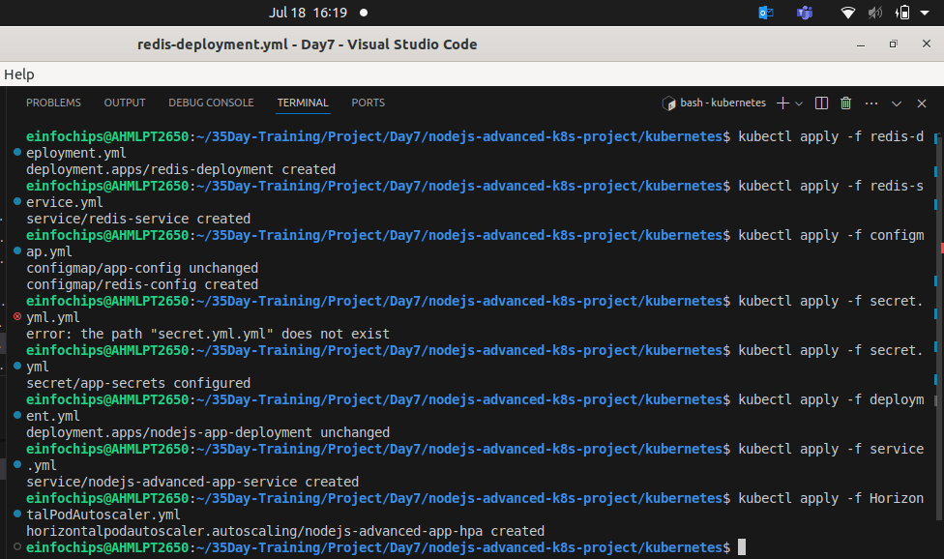

2.9 Verify Deployments and Services
Check the status of your deployments and services:

kubectl get all

Access the application via Minikube:

minikube service nodejs-advanced-app-service --url

2.10 Testing Scaling
Simulate load on the application to test the HPA:

kubectl run -i --tty --rm load-generator --image=busybox --restart=Never -- /bin/sh
# Inside the pod, run the following command to generate load
while true; do wget -q -O- http://nodejs-advanced-app-service; done

2.11 Validate Autoscaling Behavior
Observe the HPA behavior:
kubectl get hpa

Watch the scaling events and verify that the application scales up and down based on the policies you configured.

3. Project Wrap-Up

3.1 Review and Clean Up
After completing the project, review the configurations and clean up the Minikube environment if needed:

minikube delete

